**How to set mongoDB public to everyone**

**Programs needed :**

* mongoDB compass 🡪 <https://www.mongodb.com/products/compass>
* Ngrok 🡪 <https://ngrok.com>

Ngrok is a gobal distributed reverse proxy fronting your web services running in any cloud or private network on your machine.

**Setting up mongo:**

after downloading mongo db compass it will show you something like this

This will open the DB on port 27017 on the local host.

Once you connect to mongo on localhost:27017 we create a new Database named **“DTN”**

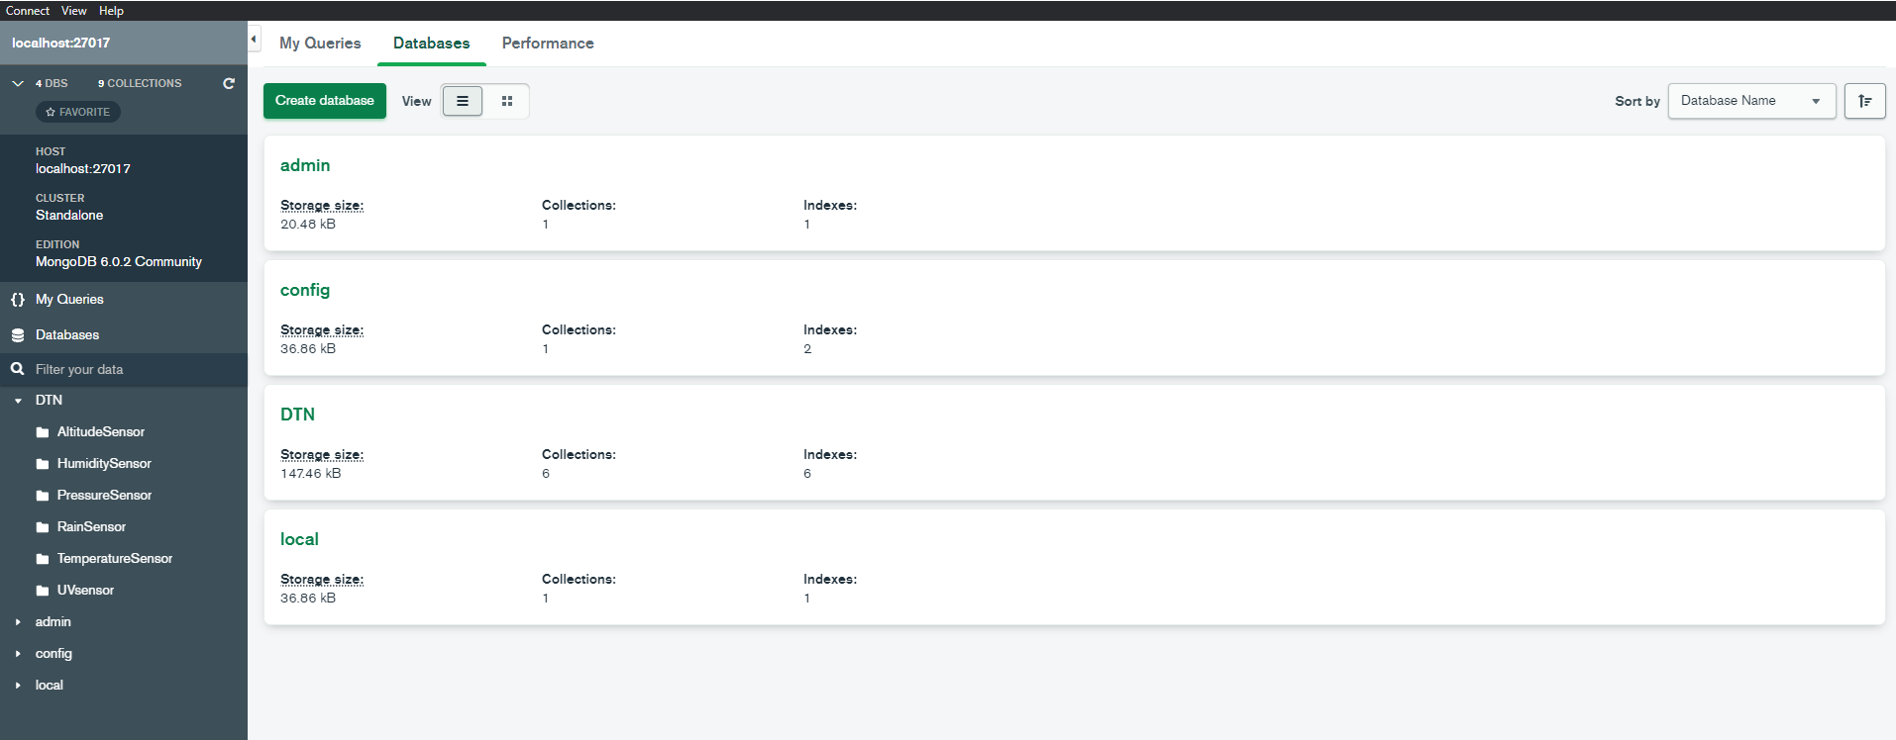

The other 3 databases showing up are there by default.

Select the DTN database and created the following collections.

If we want to connect to the Database form an “external” network, we need ngrok that is the one in charge of creating the TCP tunnel between our local host and the external actor trying to send data to it.

**Stablishing connection with mongodb and Ngrok:**

Once you open ngrok it will show this

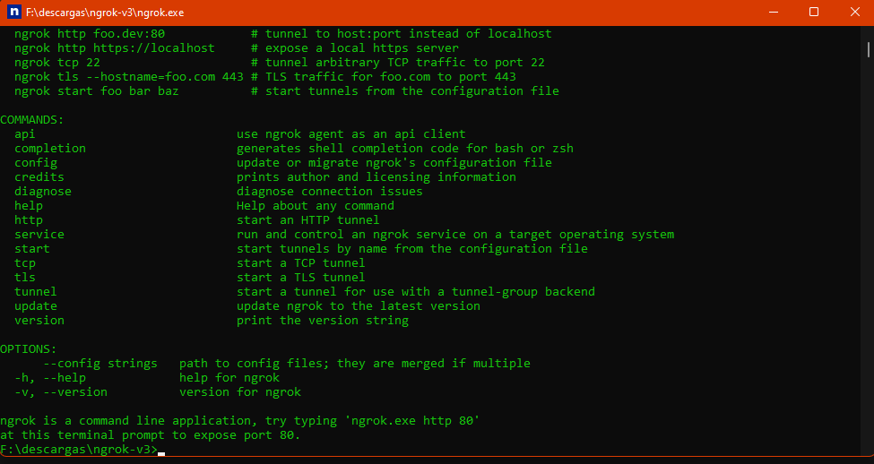

to set port 27017 (mongoDB locahost:27017) use the following command:

* Nrgok.exe tcp 27017

You will now that you set up everything correctly when the programs shows this:

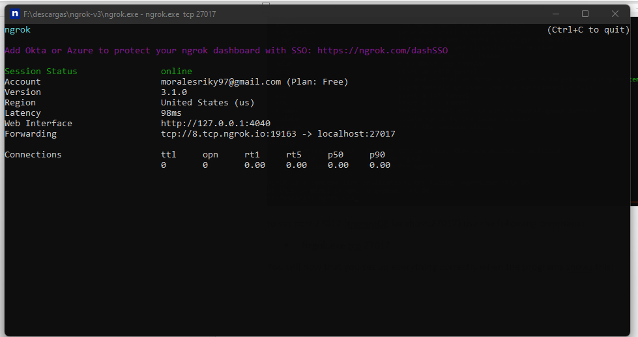

It is basically saying that if you want to reach localhost:27017 form an external network you should use the following link **tcp://8.tcp.ngrok.io:19163**

**To test connection the is multiple ways**

1. **Simple check (easy to check, not much feedback from software)**

Go to localhost in the machine that is hosting the database base and in your web browser type “localhost;27017”

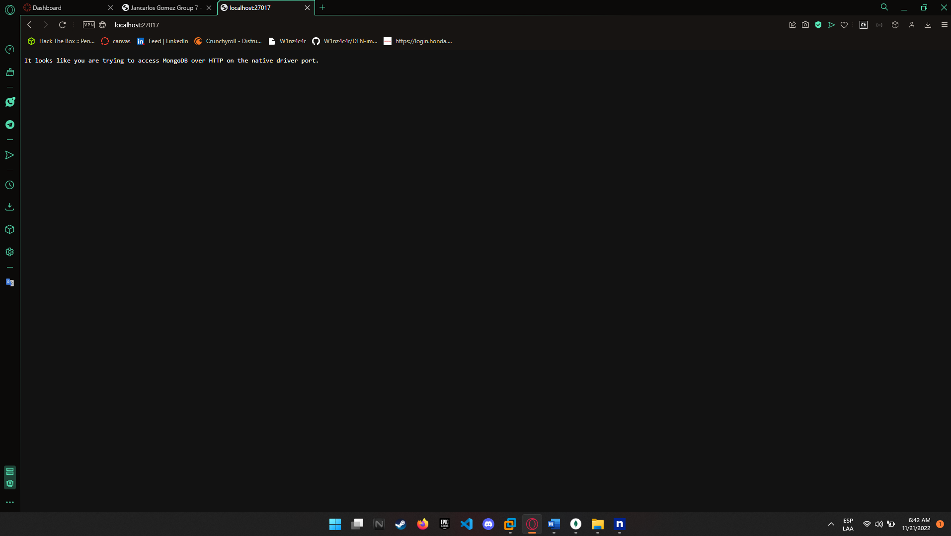

It will “connect” but its not render any more feedback about the content in the database

Then go to the link provided by ngrok, in another computer or your phone (in may case the link is tcp://8.tcp.ngrok.io:19163)

It should show up the same “content” on the two different links

1. **Connect and fetch the database (100 % sure connection is working)**

As I have been using Linux environment throughout the entire project I will **only** explain how to connect and fetch the database from a Linux console.

***You will need to download mongosh to test this way***

The command to connect to the database form Linux will be:

* mongosh --host 8.tcp.ngrok.io:19163

the host address needs to be changed for the link provided by Ngrok

After connecting you can fetch/transverse the database.

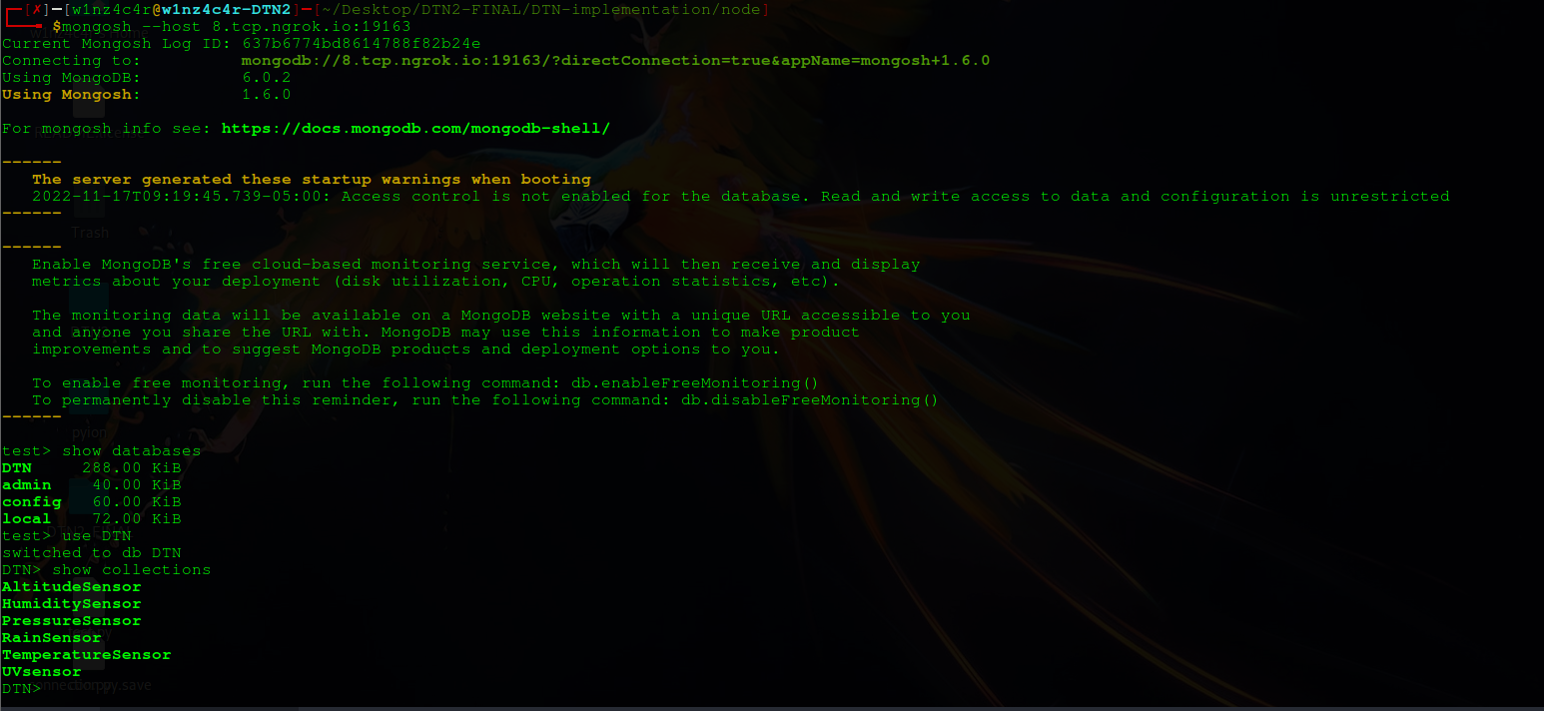

Finally, if you compare the database and collections in the host computer with the computer connection from an external network the information is the same.